Town of Indian Lake Public Library

Report to the Community

Spring, 2016

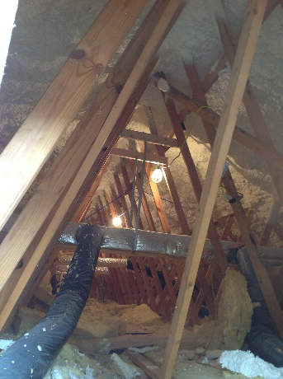
Last summer we experimented with Thursday hours from 10 am to 1 pm. We didn’t advertise, but we had customers! The Library kicked off 2016 by adjusting winter hours adding Thursdays, eliminating evenings and staying open until 6 twice a week. Responses have been positive.
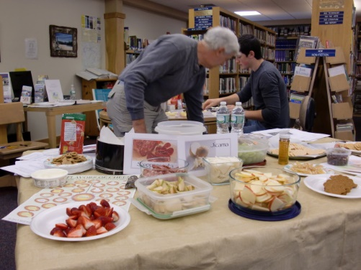
Thanks to NYS Senator Farley, the library was able to super-insulate the roof and make repairs to finally solve the icicle problem. This increased energy efficiency and comfort inside the library.
3444 people used the wi-fi in 2015 and 776 people attended 74 programs over the year. Circulation in 2015 was 15,600. Summer program plans are underway for both children and adults. Look for our “Little Free Library”—there’s more to come!
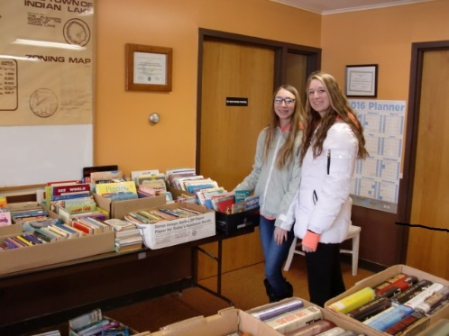
We thank you for your input and ideas which we will incorporate in to our latest strategic plan. We look forward to working with the Indian Lake Central School, the Indian Lake Theater, the Town, Blue Mountain Center and all of our partners to bring you the best library services possible.
Thanks to our volunteer library board of trustee: Ernie Pollman, President, Peg Brinkman, Mary Jean Rathbun and Sherry Williams. Regretfully, Bernadette Traeger resigned from the Board upon leaving the community. We thank her for her service and wish her the best in her new home.
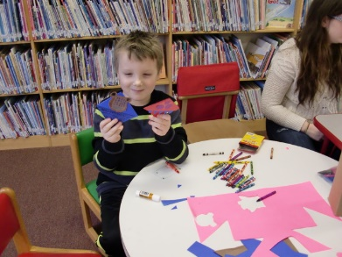
A special thank you to the Friends of the Library for their support for library programs and for Universal Class so we can all “learn something new today”!

